9. Index of First Occurrence in a String
Aim
To find the index of the first occurrence of a substring in a given string.
Algorithm
- Start.
- Read the main string and substring.
- Search for the first occurrence of the substring.
- Display the index or -1 if not found.
- Stop.
Procedure
- Get the main string and substring as input.
- Find the first occurrence of the substring.
- Display the index.
- Terminate the program.
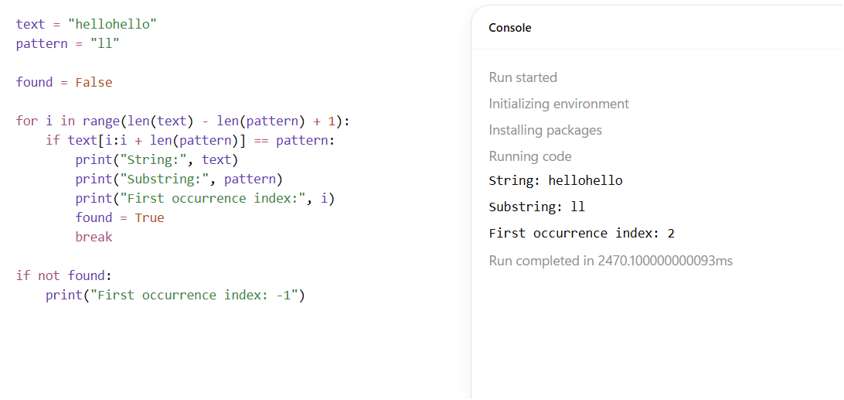
Result
The program successfully finds the index of the first occurrence of a substring in the given string.

